System Workflows and Data Processing
To further clarify the system's operation and how clinical data is handled from input to final decision, we have extracted the following technical workflow diagrams directly from the codebase logic (analysis_controler.py and analysis_service.py).
These diagrams can be included in your manuscript or supplementary materials to transparently explain the data pipeline.
1. End-to-End System Data Flow Architecture
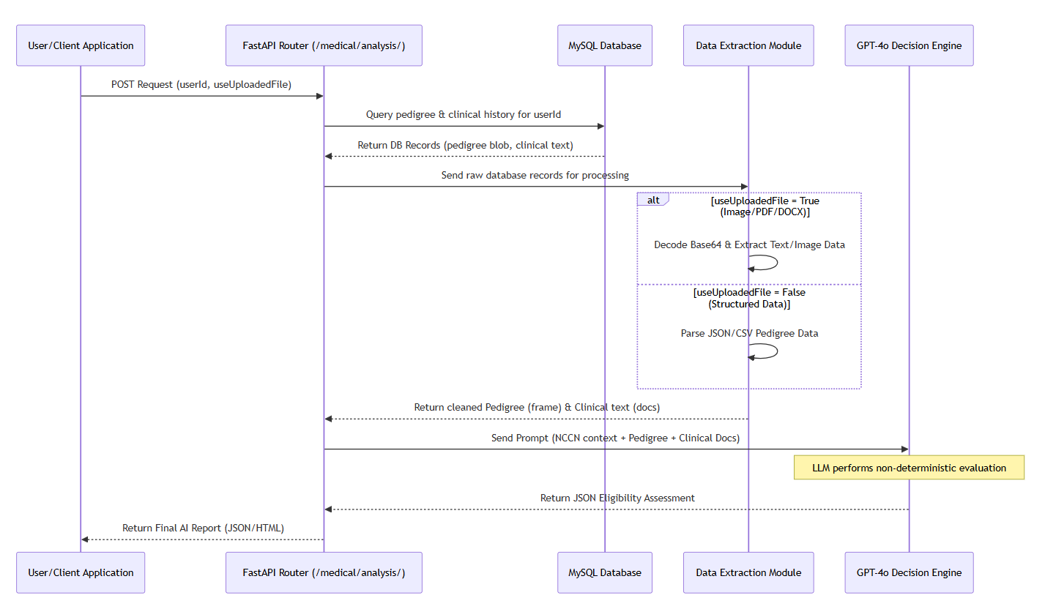
This diagram illustrates the macro-level data flow, showing how the system orchestrates user requests, database queries, and external LLM API calls to generate the final report.

2. Pedigree Data Processing Logic
A critical part of the system's robustness is how it handles varied clinical data formats. This flowchart maps the exact conditional logic used in the controller to parse pedigree information before sending it to the LLM.
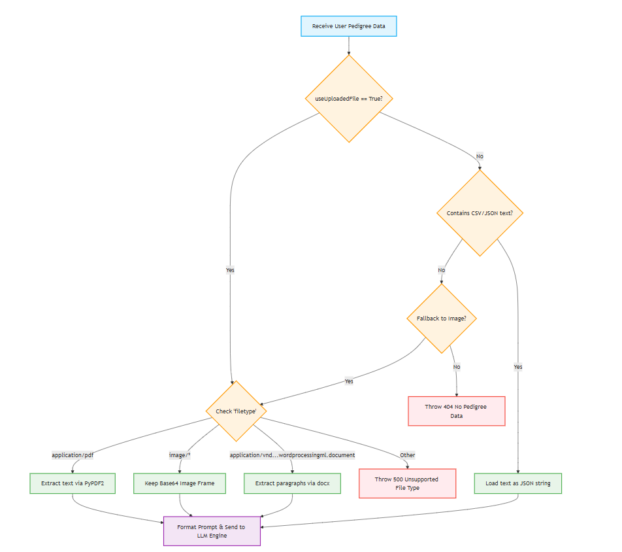
Description of Workflows
1. Data Flow Architecture: The system is built as a microservice using FastAPI. When a request is received, it securely fetches the patient's existing clinical data (histology reports) and pedigree data from a MySQL database rather than requiring direct re-upload. The system then orchestrates the parsing of this data before injecting it into the prompt payload sent to the GPT-4o API. This ensures patient data is structurally prepared before any AI reasoning occurs.
2. Multi-Modal Parsing Logic: To accommodate real-world clinical environments where data formats vary, the code features a robust, multi-modal extraction pipeline. The system dynamically detects the pedigree file type and routes it through specific parsers: extracting raw text from PDFs (PyPDF2), extracting paragraphs from Word documents (docx), maintaining Base64 encoding for direct visual analysis of pedigree images, or passing structured JSON data. This preprocessing ensures the LLM receives the cleanest possible representation of the clinical history.

